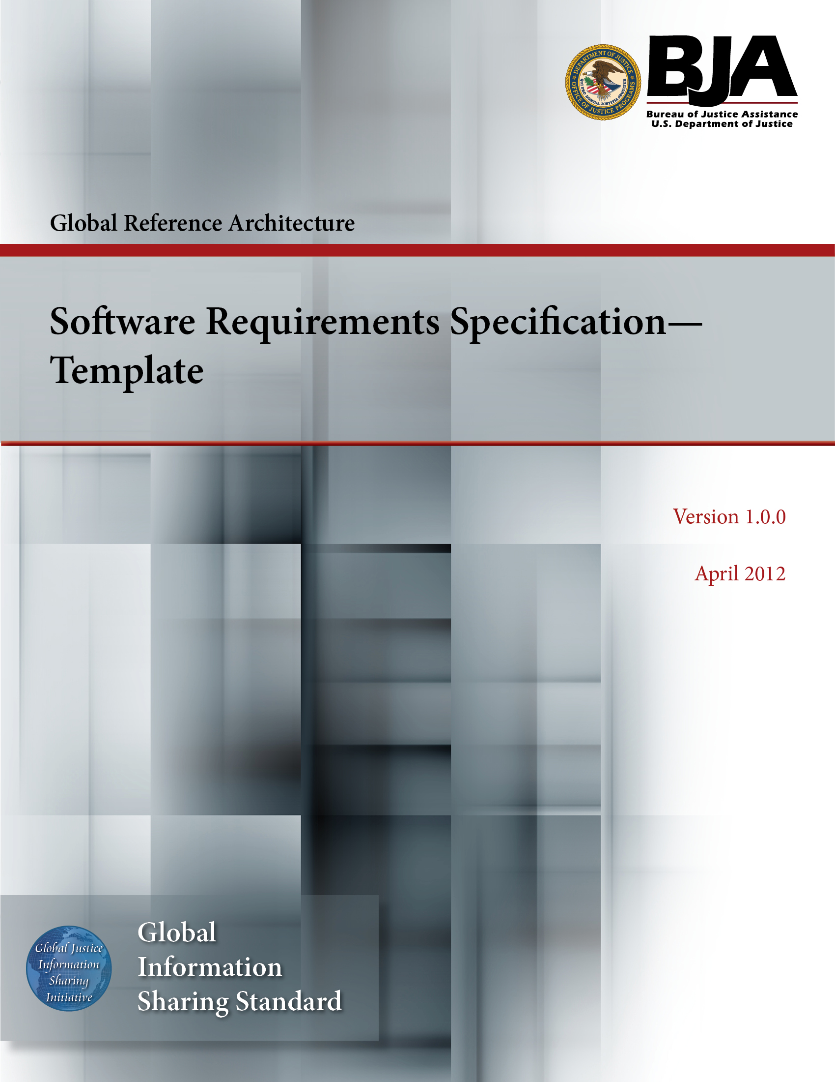


The Global Reference Architecture (GRA)

[Service Name] [Service Abbreviation] [Service Version]

Software Requirements Specification (Template)

Version 1.0.0

By [Name of Organization]

[Month Year]

Table of Contents

Document Conventions ii
1. Introduction 1
1.1 Purpose 1
1.2 Scope 1
1.3 Definitions, Acronyms, and Abbreviations 1
1.4 References 1
1.5 Overview 1
2. Overall Description 2
2.1 Use Case Model 2
2.2 Actor Descriptions 2
2.3 Use Case Descriptions 2
2.4 Assumptions and Dependencies 2
3. Specific Requirements 2
3.1 Use Case Reports 2
3.2 Supplementary Requirements 3
4. Supporting Information 3
Appendix A—References 4
Appendix B—Glossary 5
Appendix C—Document History 6

Document Conventions

[Note: The following template is provided for use with the Service Development Process. Text enclosed in square brackets and/or displayed in blue is included to provide guidance to the author and should be deleted before publishing the document.]

<Project Name> Software Requirements Specification

Introduction

[The introduction of the Software Requirements Specification (SRS) provides an overview of the entire document. It includes the purpose, scope, definitions, acronyms, abbreviations, references, and overview of the SRS.]

[Note: The SRS captures the complete software requirements for the system or a portion of the system. Following is a typical SRS outline for a project using use case modeling. This artifact consists of a package containing use cases of the use case model and applicable Supplementary Specifications and other supporting information.]

Purpose

[Specify the purpose of this Software Requirements Specification. The SRS fully describes the external behavior of the application or subsystem identified. It also describes nonfunctional requirements, design constraints, and other factors necessary to provide a complete and comprehensive description of the requirements for the software.]

Scope

[A brief description of the software application that the Software Requirements Specification applies to, what use case model(s) it is associated with, and anything else that is affected or influenced by this document.]

Definitions, Acronyms, and Abbreviations

[This subsection provides the definitions of all terms, acronyms, and abbreviations required to properly interpret the Software Requirements Specification. This information may be provided by reference to the project’s Glossary.]

References

[This subsection provides a complete list of all documents referenced elsewhere in the Software Requirements Specification. Identify each document by title, report number (if applicable), date, and publishing organization. Specify the sources from which the references can be obtained. This information may be provided by reference to an appendix or to another document.]

Overview

[This subsection describes what the rest of the Software Requirements Specification contains and explains how the document is organized.]

Overall Description

[This section of the Software Requirements Specification describes the general factors that affect the product and its requirements. This section does not state specific requirements. Instead, it provides a background for those requirements, which are defined in detail in Section 3, and makes them easier to understand. Include such items as product perspective, product functions, user characteristics, constraints, assumptions and dependencies, and requirements subsets.]

Use Case Model

[This section contains the use case model, including diagrams. An overview and description of the system is a good enclosure to this section.]

Actor Descriptions

[This section includes a list of all actors and corresponding brief descriptions. Actor descriptions are found only in this document; thus this section is required if use case modeling techniques are used.]

Use Case Descriptions

[This section includes a list of all use cases and corresponding brief descriptions. This section is directly inherited from the System Use Cases artifact, if already written.]

Assumptions and Dependencies

[This section describes any key technical feasibility, subsystem or component availability, or other project-related assumptions on which the viability of the software described by this Software Requirements Specification may be based.]

Specific Requirements

[This section of the Software Requirements Specification contains all software requirements to a level of detail sufficient to enable designers to design a system to satisfy those requirements and testers to test that the system satisfies those requirements. When use case modeling is used, these requirements are captured in the use cases and the applicable supplementary specifications. If use case modeling is not used, the outline for supplementary specifications may be inserted directly into this section.]

Use Case Reports

[In use case modeling, the use cases often define the majority of the functional requirements of the system, along with some nonfunctional requirements. For each use case in the above use case model, or subset thereof, refer to or enclose the use-case report in this section. Make sure that each requirement is clearly labeled.]

Supplementary Requirements

[Supplementary Specifications capture requirements that are not included in the use cases. The specific requirements from the Supplementary Specifications, which are applicable to this subsystem or feature, should be included here and refined to the necessary level of detail to describe this subsystem or feature. These may be captured directly in this document or referred to as separate Supplementary Specifications, which may be used as an enclosure at this point. Make sure that each requirement is clearly labeled.]

Supporting Information

[The supporting information makes the Software Requirements Specification easier to use. It includes:

- Indexes
- Appendices

These may include use case storyboards or user interface prototypes. When appendices are included, the Software Requirements Specification should explicitly state whether or not the appendices are to be considered part of the requirements.]

Appendix A—References

[This section is used to list applicable references.]

[Reference name and description] | [Fully qualified link/path to the reference information]

Appendix B—Glossary

[This section is used to list glossary terms used in the document.]

[Glossary term or acronym] | [Glossary term or acronym description]

Appendix C—Document History

[This section is used to document the history of the service description document.]

Date | Version | Editor | Change
December 11, 2011 | 1.0.0 | James Dyche  Iveta Topalova | Final 1.0.0 revision
December 20, 2011 | 1.0.0 | David Gillespie | Initial edit of 1.0.0 revision
April 2012 | 1.0.0 | Global Standards Council (GSC) | Global Advisory Committee (GAC) approved



